
4th Day Gathering = Saturday May 9th Madison Methodist Church 4:00 pm
100 Post Oak Rd. Madison, MS.

Central Mississippi Walk to Emmaus
April 2026
Greetings all members of the Central Mississippi Walk to Emmaus Community. Spring has sprung, Easter has passed us by for another year, and our Lord and Savior is still alive with us. We are now on the verge of another set of walks in the Central Mississippi Community, of which the teams have been filled, and pilgrim spots are all but complete. As we embark on this next set of walks, I pray that each and everyone of us is looking for ways to support these walks and the pilgrims who have said YES to a 3 day weekend. Lots of time, effort, thought, and consideration have gone into the preparation for walks 191 & 192, and I know that The Lord is looking to bless these walks. I pray that over the next couple of weeks each of you will take time to pray over these walks and seek out ways to encourage the team, sponsors, and pilgrims who will carry out these efforts through the events. I would like to invite each of you to come and be a part of these walks as well. Over the last 3 years, a lot of energy has gone into bringing the community back to the level that it was before the pandemic. We would love to see each and everyone take part in the community events over the next couple of weeks including send-off, candlelight, and closing. There is no better time than the present to link in and help carry this community forward.
The Board of Directors for the community has spent a lot of time over the last 6 months looking at ways to make the team composition, community website, sponsorship, and the walks, as user friendly as possible. We are striving to improve on every aspect of the community and the walk, and we would love to have everyone get involved. The progressive servanthood program is being reborn within our community to help build the teams for the walks and to ensure that we have a lineage of workers in the right places to help the community sustain with qualified leaders for many years to come. You will likely see some changes to the website in the coming months which will hopefully make the site easier to use. Our community members have been tremendous with sponsorship over the last few sets of walks. We have been able to fill or almost fill every pilgrim spot on the walks. This is a great testament to the people of this community who believe in the Emmaus Ministry and strive to send your friends, family, church members, and acquaintances to the walks as a way to share The Gospel with them. Please don’t stop now. This community has a lot of people in it and if we all strive together to grow it then The Lord will take it to levels that we can not even begin to imagine. In Matthew 4:19 Jesus said “Come, follow me, and I will make you fishers of men.” As we embark on our daily lives and striving to follow the example set by Jesus, we should also be fishing for men and women with whom we can share The Gospel. Keep in mind that God has blessed each one of us in this community with a tool in our tool belt called the Walk to Emmaus. This tool can be used to help you share The Gospel with your people and we hope that you will utilize it.
I hope that we will see each of you over the coming weeks as we share The Gospel with 2 new groups of pilgrims.
Decolores,
Chris Wiliams
CMWE Board President 2026

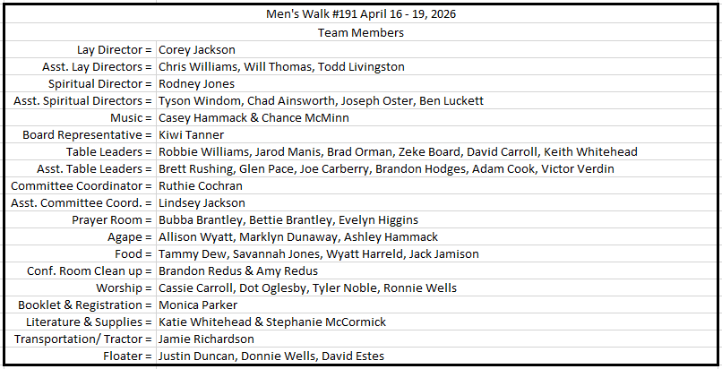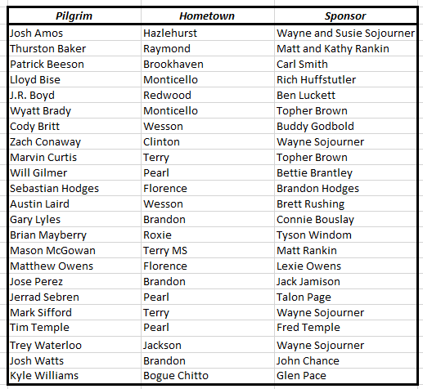

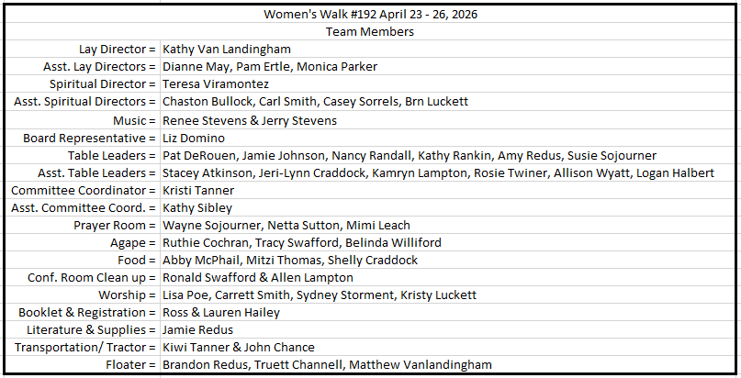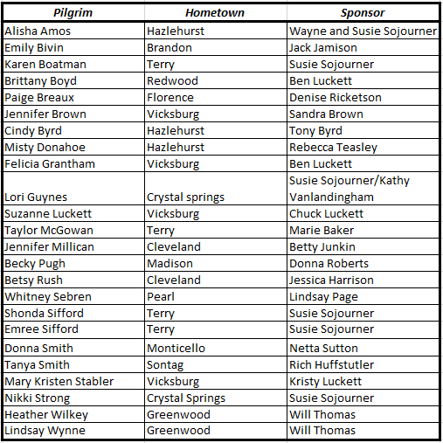
- Men's Walk #191 72 Hour Prayer Banner
- Women's Walk #192 72 Hour Prayer Banner
- Register a Pilgrim
Please Email Adam Cook at adcook704@outlook.com if you have any issues with the prayer banner, Monica Parker centralmsemmaus@gmail.com if you have any questions or concerns about registering a pilgrim for an upcoming walk.
- Registration is open for 2026 walks, remember that your registration is not complete until you pay the $25 deposit.
- If you would like to serve on a team, please be sure to complete a team registration form online.

https://www.6milecrv.com/camp

2092 6 Mile Rd, Crystal Springs, MS 39059

- Candlelight = Saturday April 18, 2026 @ 7pm
- Candlelight = Saturday April 25, 2026 @ 7pm

