
4th Day Gathering = Saturday October 25th at Madison Methodist Church 4:00 pm
100 Post Oak Rd. Madison, MS.

Central Mississippi Walk to Emmaus
October 2025
Many of you who know me know that words hold great meaning for me. I try to choose mine carefully and thoughtfully and I fail daily at filtering mine as I should. None of us is perfect, but how many of us rely on that as an excuse for poor or broken filters? The Greek word metanoia means a change of mind, an afterthought, repentance. It's easy to say that we repented of our sins when it comes to explaining salvation, but do our words actually show that? Do they continue to show that? Everyday? With everyone? Especially that one person that requires extra grace? Or in the car? When we're furious? If we took time and actually thought about what we were about to say, would we say the same thing? That's what repentance is- what happens after you thought about it, right? As you pray for these next two walks, take a moment for thought before you pray and pray with intentionality and focus. Those pilgrims and team members may not know the difference, but we will. More importantly, He will.
info@6milecrv.com
2092 Six Mile Rd
Crystal Springs, MS 39059
601.892.8885

Candlelight
7:00 PM October 11, 2025
7:00 PM October 18, 2025
Rachel Wilson CMWE Board President 2025
- Men's Walk #189 Prayer Banner
https://www.6milecrv.com/camp

- Women's Walk #190 Prayer Banner
- Register a Pilgrim
Please Email Adam Cook at adcook704@outlook.com if you have any issues with the prayer banner, Monica Parker centralmsemmaus@gmail.com if you have any questions or concerns about registering a pilgrim for an upcoming walk.
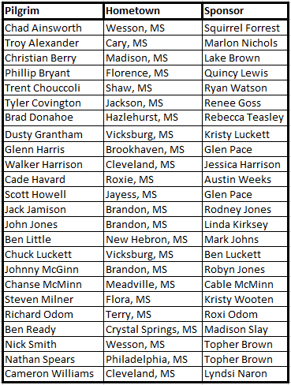

- Registration is now open for 2026 walks, remember that your registration is not complete until you pay the $25 deposit.
- If you would like to serve on a team, please be sure to complete a team registration form online.


