

**4th Day Gathering = Saturday May 10th** at Madison Methodist Church 4:00 pm

100 Post Oak Rd. Madison, MS.

***Central Mississippi Walk to Emmaus***

*Spring 2025*

*Best Walk EVER!*

*I love how we all say *that* walk was the best walk ever! And I’d like to start a trend of saying we’re about to have the best walk ever. Hear me out. Zeteo was a word used in Greek meaning seeking expecting to find. The Bible says to seek Him with all our hearts and we will find Him. We even say expect a miracle. But do we really? Do we zeteo? As we start the countdown to the Women’s Walk, I challenge all of us to intentionally zeteo as we look forward to what’s about to be the best walk ever!  
  
De Colores,*

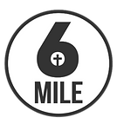

*Rachel Wilson CMWE Board President 2025*

***Candlelight***

7:00 PM April 26, 2025

*CMWE #49*

*Table of Rachel*

* [Women's Walk #187 Prayer Banner](https://docs.google.com/document/d/1o_eBNQZyRv8w72nJCcohl0kxydOJpvw31PPuFSTZfyc/edit?usp=sharing)
* [Register a Pilgrim](https://centralmsemmaus.com/blog/register-for-an-emmaus-walk/)

Please Email Adam Cook at [adcook704@outlook.com](mailto:adcook704@outlook.com) if you have any issues with the prayer banner, and Monica Parker centralmsemmaus@gmail.com if you have any questions or concerns about registering a pilgrim for an upcoming walk.

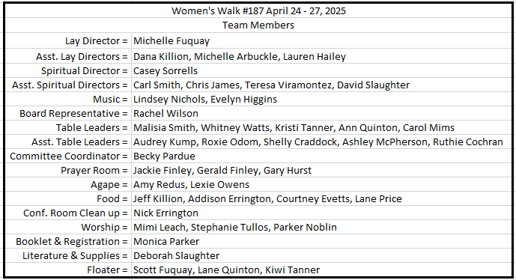

<https://www.6milecrv.com/camp>

[info@6milecrv.com](mailto:info@6milecrv.com)

2092 Six Mile Rd  
Crystal Springs, MS 39059

[601.892.8885](tel:16018928885)